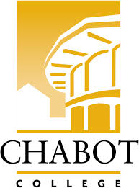**Career Education (CE Committee)**

Chabot College – Zoom

Monday, December 9, 2024

12:00-1:00

**AGENDA**

1. Welcome & Land acknowledgement - Terra
2. SOAR Day – Heather (10 min)
3. CE Open House – Robin & Yvonne
4. CE - Student Success Stories - Robin
5. Good of the Order - Kristina
6. Next Meeting 2/10/2025
7. Adjournment

**Mission Statement**

*Chabot College is a dynamic, student-centered community college that serves the educational, career, job skill, and personal development needs of our community. We provide culturally responsive, revitalizing, and sustaining learning and support services driven by a goal of equity. Building upon students’ strengths and voices, we empower students to achieve their goals and lead us towards an equitable and sustainable world.*